Information Package


Signals Training Manual

This manual will cover all of the needed steps and procedures which are to be implemented and enforced in 5R Comms.

Radio types and ranges

Radios are generally divided into 2 types, Long Range radios (LR) and Short Range Radios (SR). SR radios typically have a range of 5km while LR radios can go up to 20KM, they function in different bands (frequency ranges) though there is some overlap.

Advanced AN/PRC-152 operation

Multiple types of PRR radio exist but we will be focusing on the AN/PRC-152 as it is the most common. Remember that channel is only a slot in your individual radio’s memory, to talk to someone all you need is their frequency. The AN/PRC-152’s band spans from 30MHz to 512MHz. This Radio has a range of 5KM, the further apart, the worse the signal.

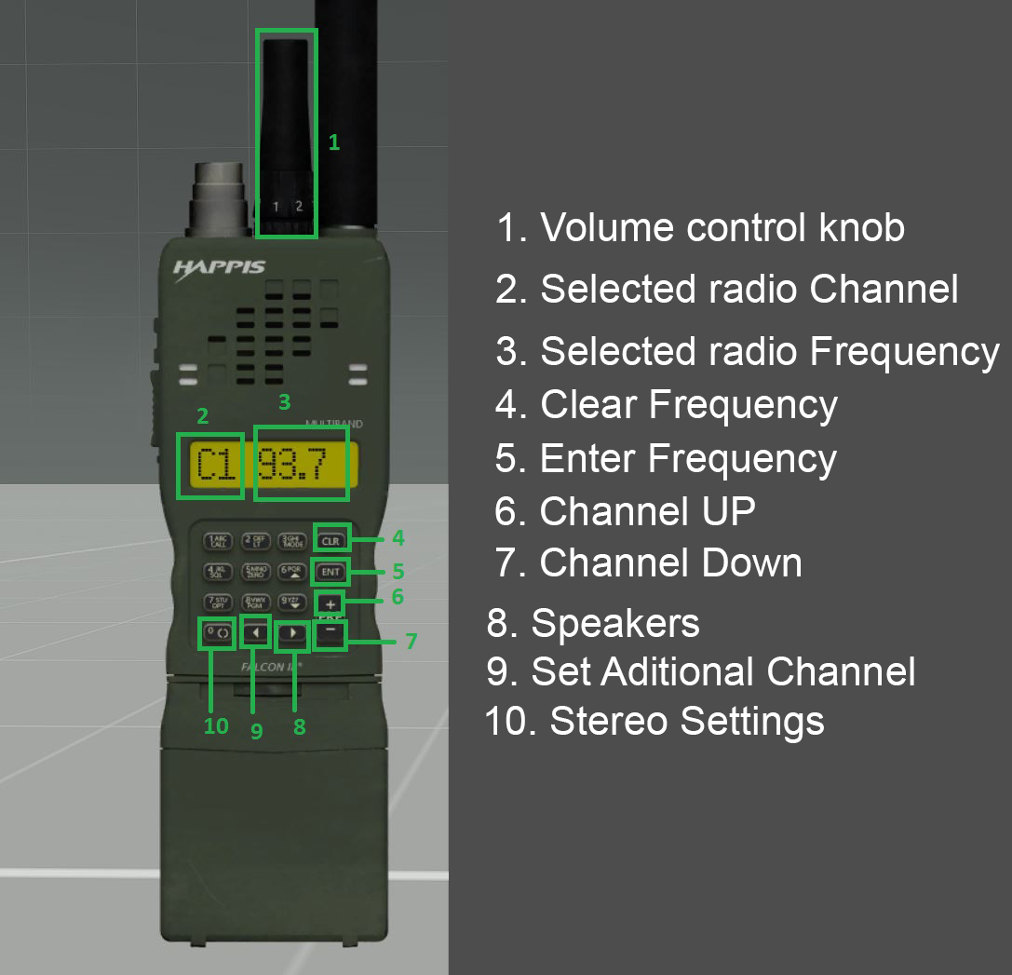

This radio is capable of Stereo which can be accessed by using the STEREO SETTINGS key and cycling through multiple options, if an alternate channel has been set it can be individually controlled by using the same button while the alternate channel is selected.

Advanced AN/PRC-155 operation

The AN/PRC-155 is much like its PRR counterpart, all of the features in this radio mirror the AN/PRC-152’s. This radio’s band spans from 30MHz to 87MHz. This Radio has an effective range of 10-20KM in backpack form, and 15-30KM when embedded in Vehicles.
You must take into account: mountains and forests will reduce your range by up to half or more.
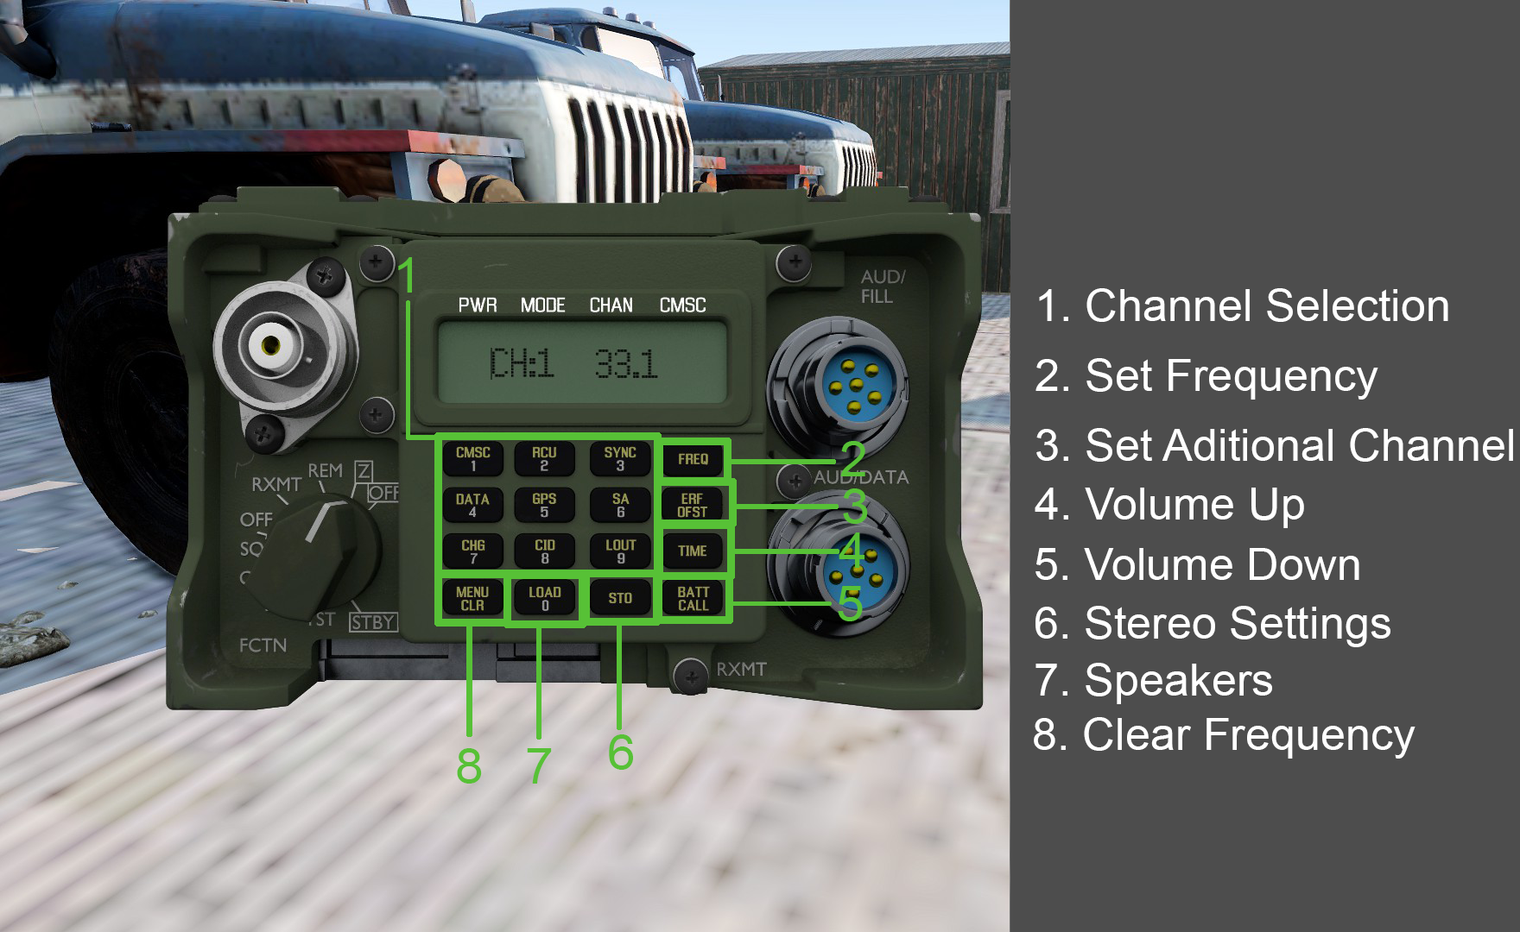

While using 2 radios it's often best to make use of the stereo settings, setting one radio to the right ear and another to the left.

Both Radio sets are capable of setting an alternate channel, to do so select a channel, set it to the desired frequency and press the SET ALTERNATE CHANNEL button, then put the radio back to your primary channel.
Extension of the LR radio can be done with an antenna, which will extend the range of the LR radio; they have to be placed and only takes effect when connected.

Depending on the Operation, some range extenders are available to Platoon commanders: the SATCOM Antenna and Radio Relay boxes (15km extension of broadcast, deployable via LSS and air lift.)

Introduction to Voice Procedure (VP)

VP is a ruleset used for communication, made necessary by multiple users on the same net, it allows messages to be clear and quick, minimising airtime and simplifying the message while maximising information given.

VP is to be used and enforced only on LR radio, SR radio enforcement is at the discretion of the Section Comd.

The ABC’s of Radio Comms

This is the base principle of VP, this can be applied to any radio transmission, especially to be used on the main radio net (30)

The ABC’s are a message that looks like:
A - Accurate
B - Brief
C - Clear

These should be the beginning gates we should put our message through before even pressing the radio button.

Message structure

Once we have our message in mind we can then apply it to the message structure.

1 - Hello
“Hello” is a necessary step because it provides a buffer for receivers to realise there's a transmission happening and to listen for the callsign it is addressed to.
2 - Recipient
“Recipient” is to be replaced by whoever you are trying to get into contact with
3 - This is Sender
“Sender” is to be replaced with your own callsign.
4 - Message
The message you want to transmit.
5 - Over
Saying “over” lets the recipient know that you are waiting for their callback so that you can pass along your message once they are ready.

An Average transmission over Radio Net 30 should look as so;
“Hello 0, this is 2-1, Requesting Permission to cross Phase Line Delta, Over”
“0, Afirm, Cross Phase Line Delta, Time Now, Out”

RADIO CHECK

Initiates Radio Check procedure, answers are to be given;
OK - Reads perfectly.

DIFFICULT - Reads, but with difficulty.
UNWORKABLE - Transmission can be heard, but wording is impossible to understand.
NOTHING HEARD - No response heard at all.

ELS Request
The Engineering and Logistics Section are our unit in which we receive our logistical support, whether that be Rearms, Repairs, or Pathfinding. Important information that the ELS needs is as listed below;

WHAT - ELS needs to know what you need, Ammo, Rearm etc. so they can bring / prepare the correct equipment as required.

WHERE - ELS needs to know where you are / where you are going to meet them so they can be en route as soon as possible.

WHEN - Emergent situations happen, so ELS needs to know if you need them immediately, or whether they have a few minutes to prepare and meet you as required.

SECURITY STATE - ELS needs to know whether they will be conducting their job under sustained fire, or whether they will be safe to conduct their job without threat to life.

ACE REPORTING

ACE Reports are key information for Command elements to hold to ensure that the combat elements underneath them are in a fighting state and are able to continue the mission as required.

ACE stands for;
AMMO state - How many Magazines/Ammo Belts you have. Feedback is given in the following 4 states;
Green - 7+ Magazines, or 600+ Machine Gun Links.
Amber - 3-6 Magazines, or 300-600 Machine Gun Links.
Red - 1-2 Magazines, or under 200 Machine Gun Links.
BLACK - OUT OF AMMO.

CASUALTY state - Situation of infantry and any wounded. Feedback is given in the following 4 states;
Green - Section is 100% Combat Effective.
Amber - Section is down to 75% Combat Efficiency.
Red - Section is down to 50% Combat Efficiency.
BLACK - Section is down to 25% Combat Efficiency.
Red or BLACK situations usually result in a MASCAS situation.
EQUIPMENT state - Special Equipment, I.E Rocket Launchers, Medical Equipment, Grenades. Feedback is given in the following 4 states;
Green - Full ammo/medkits.
Amber - Enough to survive another combat encounter.
Red - Not enough to start another combat encounter.
BLACK - OUT OF AMMO/Med supplies.

Pro-Word Dictionary

1. Message Control
Pro-Word | Meaning | Example (ARMA/TFAR context)
OVER | I have finished my transmission and expect a reply. | “1-2, this is 1-1, message, over.”
OUT | I have finished my transmission and do not expect a reply. Do not use “Over and Out” together. | “Zero, this is 1-1, RTB complete, out.”
WAIT | I must pause for a short time; I will call you back. Usually followed by a time in minutes. | “1-2, this is 1-1, wait two, out.”
WAIT OUT | I will call you back; do not reply until I do. | “Contact, wait, out.”
SAY AGAIN | Repeat all of your last transmission. | “Say again your last, Over.”
SAY AGAIN, ALL BEFORE / ALL AFTER | Repeat only the portion before or after a certain phrase. | “Say again, all after grid one-two-three.”
WRONG | An error has been made; the correct version follows. | “Grid one-two-three-four-five-nine – wrong – one-two-three-four-five-six.”
ROGER | Confirm you have received and understood this message. | “Roger, over.”

2. Reports & Requests
Pro-Word | Meaning | Example
ACE REPORT | Ammo, Casualties, Equipment status report – usually after contact. | “ACE report: Green, Green, Amber.”
LOCSTAT | Location status – your current position. | “LOCSTAT, grid 123456.”
SITREP | Situation report – what you’re doing, where, and why. | “SITREP: Defence, grid 123456, awaiting resupply.”
Sighting REPORT | Used to transmit enemy locations which haven’t been engaged as of yet. | “Sighting report, Enemy APC, 600m, Location marked on map, Over.”
ELS  REQUEST | Request logistic, repair, or rearm support. What you need, Where you need it, When you need it and is it safe? | “ELS request, grid 123456, vehicle rearm, time now, area safe, over”

3. Contact & Combat Calls
Pro-Word | Meaning | Example
CONTACT | You are being engaged or engaging the enemy. | “CONTACT, wait out.”
MASCAS | Mass casualties – net goes silent until 0 replies to MASCAS call. | “BREAK BREAK BREAK, Hello 0 this is 1-3, MASCAS, MASCAS, MASCAS, Please advise, over.”
SIGHTING | Enemy sighted but has not seen you. | “Sighting report, enemy section, grid 123456, moving north, time now, over.”

4. Special Instructions
Pro-Word | Meaning | Example
BREAK | I am pausing for a moment; more to follow. | “Move to grid 123456, BREAK, establish OP.”
BREAK, BREAK, BREAK | Immediate silence on net for urgent message. | “BREAK BREAK BREAK, enemy MBT, south, 500m.”
CHARLIE CHARLIE | Grouped call signs to be addressed together. | “Charlie Charlie One – meaning 1-1, 2-1, 5-1 – move to RP1.”
MESSAGE | Preface to a long radio transmission. | “Hello 1-2, this is 0, message, over.”
I SPELL | Spelling a word phonetically. | “I spell Bravo, Romeo, November, Oscar – BRNO.”
RELAY | Relay a message to another call sign. | “Relay to 2-1: grid clear.”
FIGURES | Transmitting numbers over “9”. | “Figures one, five – meaning 15.”
ROGER | I have received and understood your message. | “Roger, over.”
ROGER SO FAR | Confirm partial message understanding so far. Used by both sender and receiver. | “... Roger so far, Over?”  “0, Roger so far, Over.”
WILCO | Will comply. | “Wilco, moving now.”

5. Command Call Signs
Pro-Word | Meaning | Example
SUNRAY | Commander of a call sign. | “0 this is 1-2 Sunray, over.”
SUNRAY MINOR | Second-in-command of a call sign. | “0 this is 1-2 Sunray Minor, over.”
ZERO | Company HQ net control station. | “Zero, this is 1-1, over.”
ZERO ALPHA | Officer Commanding (OC). | “Zero Alpha, this is 1-1, over.”
ZERO BRAVO | Second-in-command (2IC). | “Zero Bravo, this is 1-2, over.”
ZERO CHARLIE | Company Sergeant Major (CSM). | “Zero Charlie, this is 1-3, over.”

Signals - Training package
5Ranger – Introduction to Signals
Instructor Script & Training Guide for New Players

Lesson Aim
Introduce new players to 5Ranger’s radio communication standards using TFAR, focusing on clarity, brevity, and correct military phraseology.

Learning Objectives
By the end of this session, trainees will:
- Understand the purpose of radio discipline in milsim.
- Be able to operate basic SR/LR radios in TFAR.
- Use ABC principle to form transmissions.
- Deliver a properly structured radio message.
- Apply common prowords in practice.

Lesson Duration
30-50 minutes

Instructor Introduction (Script)
“Welcome to 5Ranger Signals training. In ARMA, your radio is your lifeline — poor comms will lose you the mission, but good comms will win it.
Today, we’re not just learning buttons. We’re learning how to talk like a soldier, so that in combat, there’s no confusion, no wasted time, and no mistakes.
We’ll start with the basics of your radio, move into how we format a message, and finish with a live drill.”

Module 1 – Purpose of Comms Discipline
Instructor Talking Points:
- Why: Multiple players share one net; without discipline, the net becomes chaotic.
- Golden Rule: Try and make the message Quick, Understandable, and Clear.
- Comms ≠ conversation; they’re for essential mission information only.
Instructor Script:
“Your section, platoon, and company all share airspace on the net. Every extra second you talk is a second someone else can’t. In a firefight, that can kill people. We use ABC — Accurate, Brief, Clear — as the filter before we key up.”

Module 2 – Your Radio in TFAR
Short-Range Radio (AN/PRC-152)
- Range: ~5 km; used for section-level comms.
- Open interface: Ctrl + P
- Talk: Caps Lock
Long-Range Radio (AN/PRC-155)
- Range: ~20 km (backpack) / ~30 km (vehicle).
- Open interface: Alt + P
- Talk: Ctrl + Caps Lock

Set an Additional Channel:
  - Tune to your primary frequency.
  - Switch to another channel slot.
  - Set secondary frequency.
  - Click “Set Additional Channel.”
  - Assign to left or right ear.
  - Return to Primary Frequency
Range extenders keep your signal alive in difficult terrain. Use them correctly.
- Whip Antenna: Extends LR range from ~20km to ~25km.
Deploy via ACE Self-Interact → Equipment → Attach Antenna.
- SATCOM Antenna: Deployable; greatly boosts range within ~5m.
Place via ACE Self-Interact → Equipment → Place Antenna.
Not used by infantry
TFAR Key Points:
- SR interface: Ctrl + P
- LR interface: Alt + P
- Talk on SR: Caps Lock
- Talk on LR: Ctrl + Caps Lock
Instructor Script:
“Your short-range is for your section; long-range is for command nets. In 5Ranger, you will normally be issued a short-range by default. Platoon staff and certain vehicle crew also get a long-range.”

Module 3 – ABC Principle & Message Structure
ABC Principle:
- A – Accurate: Is your info correct?
- B – Brief: Use the fewest words needed.
- C – Clear: Avoid slang, keep language simple, and follow the Pro-Word requirement.
Message Structure:
- Hello – alerts net.
- You – the callsign you’re talking to.
- This is Me – your callsign.
- Message – the message.
- Over – hand control back.
Example:
“Hello 0, this is 2-1, permission to cross Phase Line Delta, over.”
“0, yes yes. cross Phase Line Delta now, out.”

Instructor Script:
“We always start with the recipient, then identify ourselves. Never just speak into the net without saying who you are — it wastes time while everyone tries to guess.”

Module 4 – Essential Prowords
Common Prowords for Beginners:
- Over – My turn is done, expecting reply.
- Out – My turn is done, no reply needed.
- Say Again – Repeat your last transmission.
- Roger – I understand.
- Wilco – I will comply.
- Wait – Standby.
- Break – Pause in message; more to come.
- Break, Break, Break - Emergency Transmission to follow.
- Contact – We are in enemy contact.
Instructor Script:
-Read Pro-words, explain them to the best of your ability
“We use these words to keep comms clean and universally understood. Avoid normal conversation — ‘Copy that’ becomes ‘Roger.’ ‘Hold on’ becomes ‘Wait.’”

Module 5 – Basic Radio Check Procedure
Steps:
- “Hello [callsign], this is [your callsign], radio check, over.”
- Expect reply: “OK” / “Difficult” / “Unworkable” / “Nothing Heard.”
- Reply “Ok, Over”.
Instructor Script:
“Always do a radio check before stepping off on an op. This ensures your net is working before bullets are flying.”

Practical Drill Plan
Setup:
- All trainees on same TFAR net for LR.
- Instructor roleplays as command callsign “0.”
Exercise Flow:
- Each trainee calls 0 with a radio check.
- Each trainee sends a correctly formatted message using ABC.
- Each trainee uses at least one proword in a response.
- Instructor injects a “Contact” report scenario.
End State:
Trainees can:
- Call someone correctly on the net.
- Send an ABC-formatted message.
- Use prowords instead of casual speech.

End of Lesson Script
“Good comms keep us alive and win missions. In 5Ranger, we expect every player to be confident in keying up, saying exactly what’s needed, and then getting off the net.
Practice this in every game — the more you do it, the more it becomes second nature.”

